6. Print Invoices

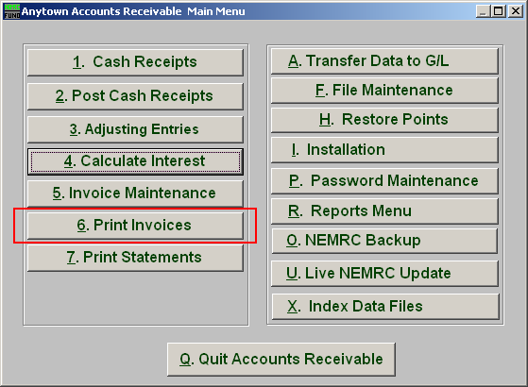
Click on “6. Print Invoices” from the Main Menu and the following window will appear:

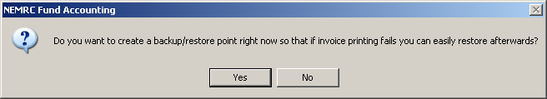
You should choose “Yes” when this notice appears. It is always very important that you backup your data. Keep in mind that this only backs up the data for the module and entity that you are in. Keep in mind that Restore Points are not a substitute for the regular backup routine.

After the Restore Point is made, the following window will appear:
Print Invoices

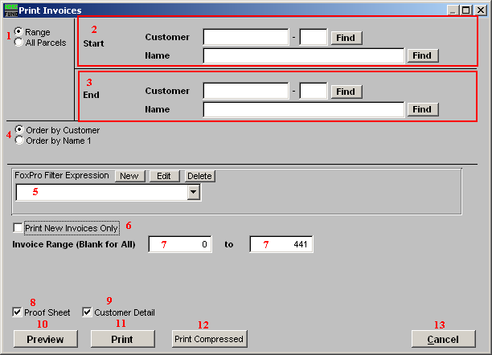

- Range OR All Parcels: Choose “Range” if you want to print a range of invoices. Choose “All Parcels” if you want to print invoices for all Customers.

- Start: If you chose “Range”, select the Customer you want to start with by typing in the Customer Code or Name or click “Find” and select from the menu.

- End: If you chose “Range”, select the customer you want to end with by typing in the Customer Code or Name or click “Find” and select from the menu.

- Order by Customer OR Name1: Select “Order by Customer” if you want the invoices to print by Customer Code or select “Order by Name 1” if you want the invoices to print by Customer Name.

- FoxPro Filter Expression: A conditional reporting expression developed with NEMRC support. This evaluates account information to determine if the account should be included. Contact NEMRC support to learn more about this option.

- Print New Invoices Only: The system offers to mark invoices as printed during entry and after printing. Those not marked can be selected to be the only invoices to print by checking this box.

- Invoice Range: The default is to print all invoices in the system. You can change the invoice number range to print here.

- Proof Sheet: Check this box to print an invoice proof sheet instead of actual invoices for reviewing.

- Customer Detail: Check this box to print each individual customer’s invoices when in proof sheet mode. A summary by billing code will still be printed.

- Preview: Click this button to preview. Refer to GENERAL PREVIEW for more information.

- Print: Click this button to print. Refer to GENERAL PRINTING for more information.

- Print Compressed: Click this button to print the report. This is different from the “Print” option in that it will use less paper for the same report.

- Cancel: Click “Cancel” to cancel and return to the previous screen.

